Task on Relational Database Service (RDS)

- Create MariaDB DB on EC2.
Standard Pattern to Follow for Every Task
Task Title
Create MariaDB Database on EC2 & Take Backup
Objective
Deploy an EC2 instance, install MariaDB, create a sample database, insert dummy data, and take a backup using mysqldump.
Prerequisites
List all requirements before starting:
• VPC
• Public Subnet
• Security Group allowing SSH (22) & DB Port (3306)
• Key Pair
• IAM Role (Optional: SSM Access)
• Amazon Linux 2023 AMI (recommended)
• NAT Gateway / Bastion Host (If instance in private subnet)
• Route Tables configured correctly

Step-by-Step Implementation (With Evidence)

Step 1: Launch EC2 Instance
• Console path: EC2 Console → Launch Instance
• Choose AMI: Amazon Linux 2023
• Instance Type: t2.micro
• Configure SG: Allow port 22 & 3306
• Key pair: Select existing (avengers)
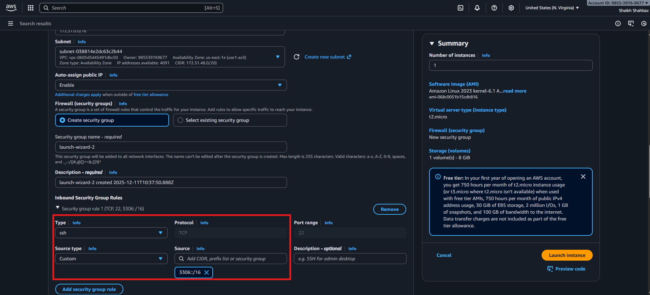
Explanation:
This EC2 instance will host the MariaDB server.
Evidence:
• EC2 instance details page screenshot
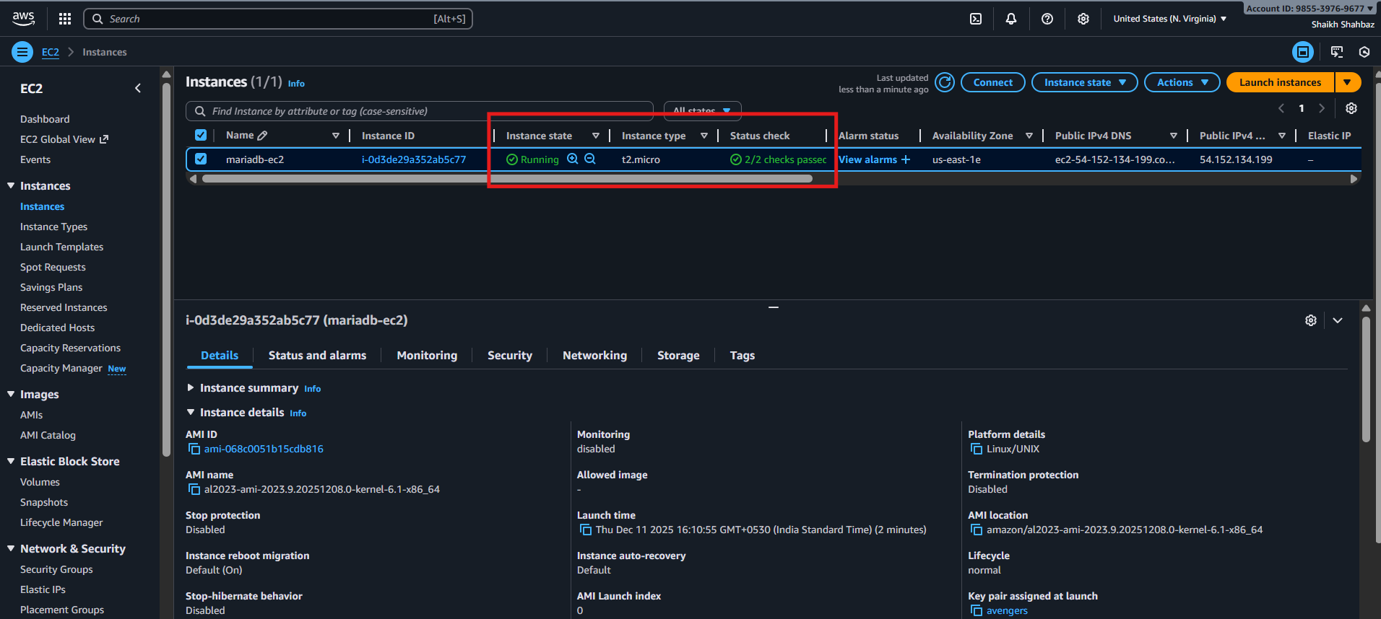
Step 2: Connect to EC2 via SSH
Command:
ssh -i "your-key.pem" ec2-user@<EC2-Public-IP>
Explanation:
We are logging into the server to install MariaDB.
Evidence:
• SSH terminal screenshot
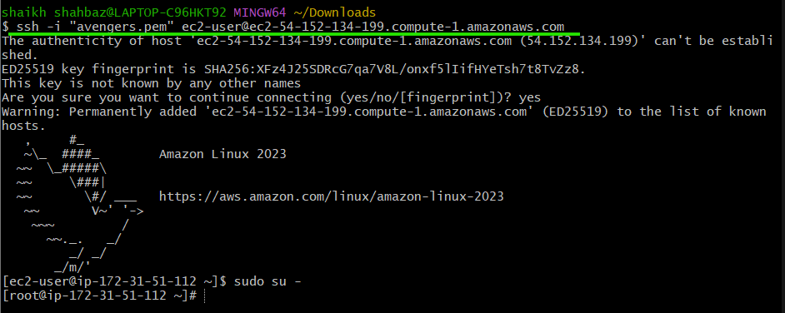

Step 3: Install MariaDB Server
Commands:
sudo yum update -y
sudo yum install mariadb105-server -y
sudo systemctl start mariadb
sudo systemctl enable mariadb
Explanation:
Installs and starts MariaDB service.
Evidence:
systemctl status mariadb output
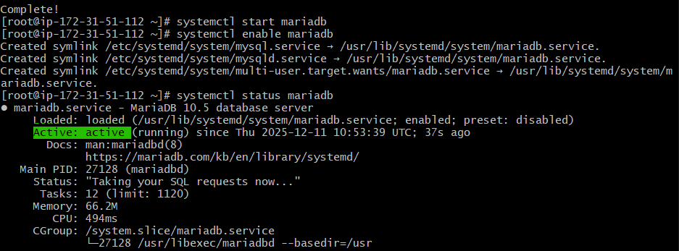
Step 4: Secure the MariaDB Installation
Command:
sudo mysql_secure_installation
Explanation:
Sets root password & removes anonymous test accounts.
Evidence:
Terminal output
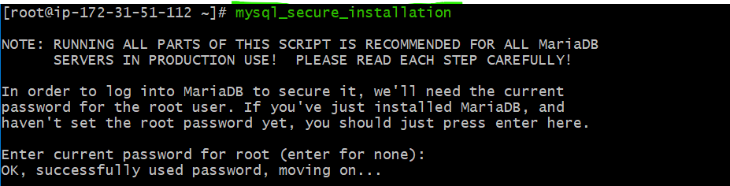
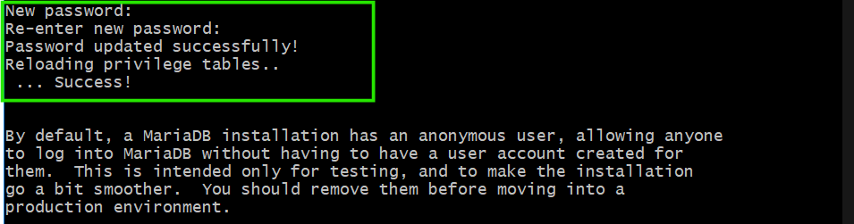

2. Insert some dummy data.

Step : Create Database & Insert Dummy Data
Command:
sudo mysql -u root -p
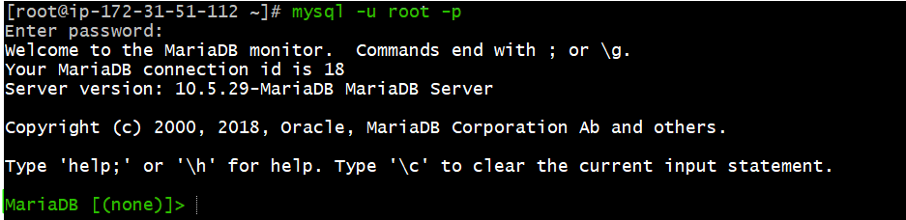
Inside MariaDB:
CREATE DATABASE company;
USE company;

CREATE TABLE employees ( id INT PRIMARY KEY AUTO_INCREMENT,name VARCHAR(50), role VARCHAR(50));

INSERT INTO employees (name, role) VALUES
('Arjumand','DevOps Engineer'),('Awais','Cloud Architect'),('Waseem','DBA');
Explanation:
Creates database, table, and inserts sample rows.
Evidence:
SELECT * FROM employees; screenshot
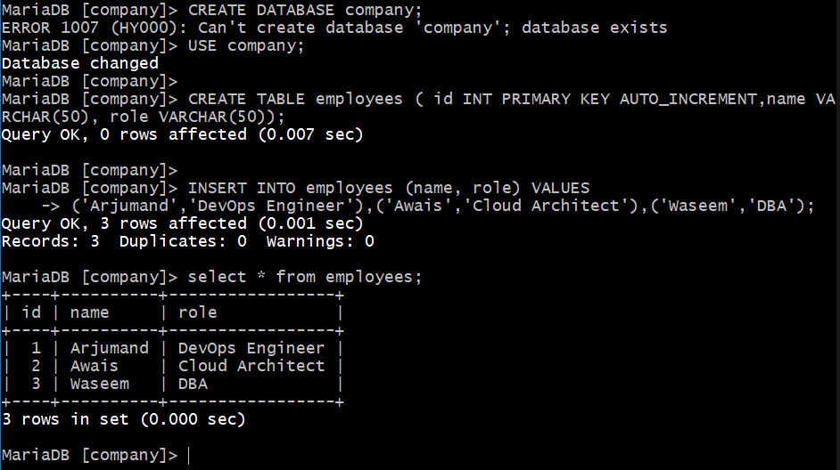

3.Take the backup of dummy data on EC2.
Steps to take backup :
Step : Take Backup of Dummy Data
Command:
mysqldump -u root -p company > company-backup.sql
Explanation:
Creates a SQL backup file of the entire database.
Evidence:
ls -l company-backup.sql output
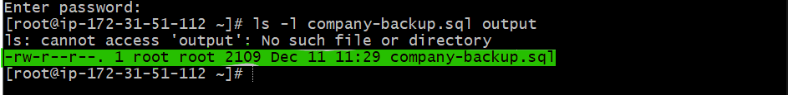
Validation Steps

Validation 1: Resource Health
EC2 instance running & MariaDB service active.
Evidence:
• EC2 status screenshot
• systemctl status mariadb
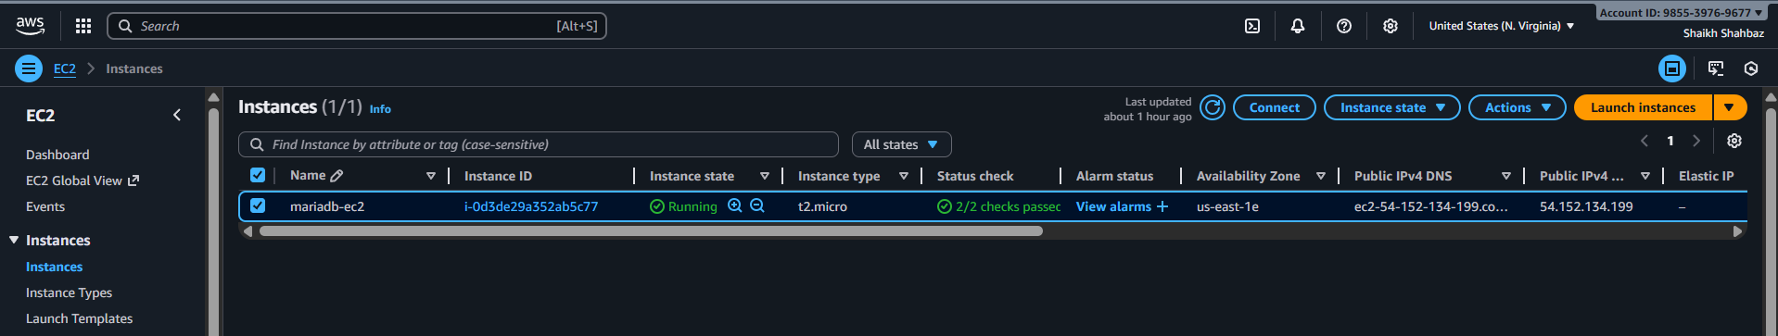
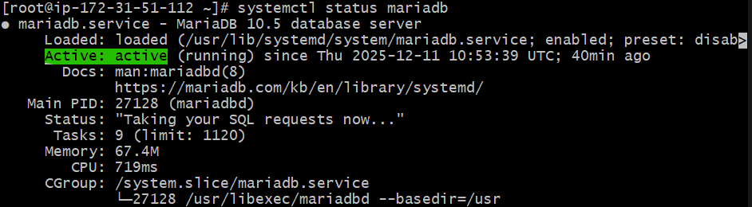
Validation 2: Functional Check
Database accessible and dummy data exists.
Evidence:
• SELECT * FROM employees; output

Issues Faced (Optional but Recommended)
• Yum repo issue while installing MariaDB → Fixed by updating packages.
• MariaDB service failed initially → Restarted and enabled SELinux policy.

Conclusion
MariaDB was successfully installed on EC2, dummy data inserted, and full database backup taken using mysqldump.

4.Launch MariaDB RDS instance.
Task Title
Launch MariaDB RDS Instance.
Objective
Provision a managed MariaDB RDS instance and migrate the previously created
Prerequisites
List all requirements before starting:
• VPC
• Public & Private Subnets
• DB Subnet Group (Mandatory)
• Security Group allowing port 3306
• EC2 instance
• company-backup.sql file present on EC2
• Route Tables correctly configured

Step-by-Step Implementation

Step 1: Create an RDS Subnet Group
• Console path: RDS Console → Subnet Groups → Create DB Subnet Group
• Select at least 2 private subnets across 2 AZs
Explanation:
RDS requires a DB subnet group for Multi-AZ availability.
Evidence:
• Subnet group details screenshot
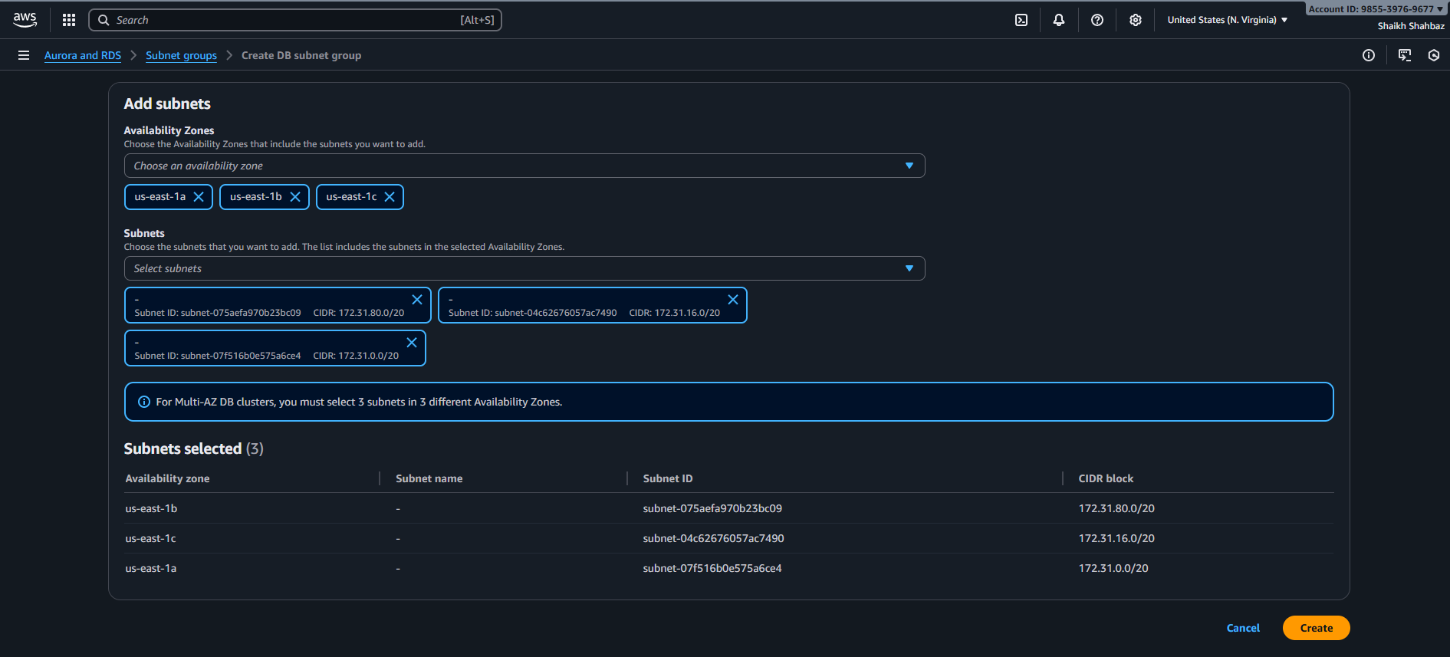

Step 2: Launch MariaDB RDS Instance
• Console path: RDS Console → Create Database
• Engine: MariaDB
• Template: Free Tier
• DB Instance Identifier: mariadb-rds
• Credentials: admin / password
• DB Instance Class: db.t3.micro
• Storage: 20GB gp2
• Connectivity:
- Select your VPC
- Subnet Group: DB Subnet Group you created
- Public Access: No
- Security Group: Allow access from your EC2 SG
Explanation:
Creates a fully managed MariaDB instance inside private subnets.
Evidence:
• RDS instance creation screenshot
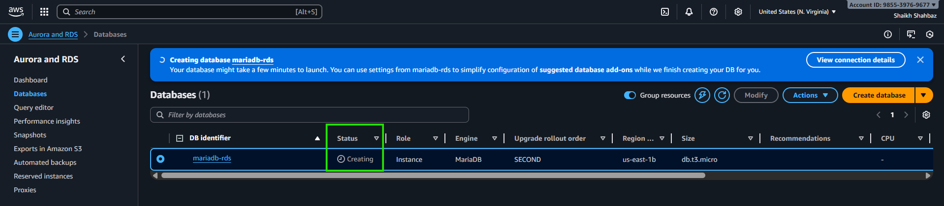
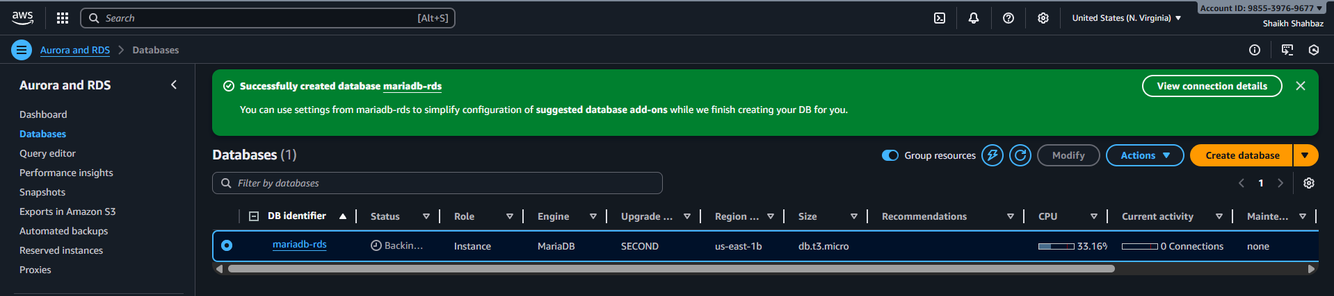
Step 3: Copy Backup File to RDS-Accessible Location (EC2 only import)

Backup already on EC2 from Task 1:
company-backup.sql
Evidence:
ls -l company-backup.sql

Step 4: Connect From EC2 to RDS Instance
Command:
mysql -u admin -p -h <RDS-endpoint>
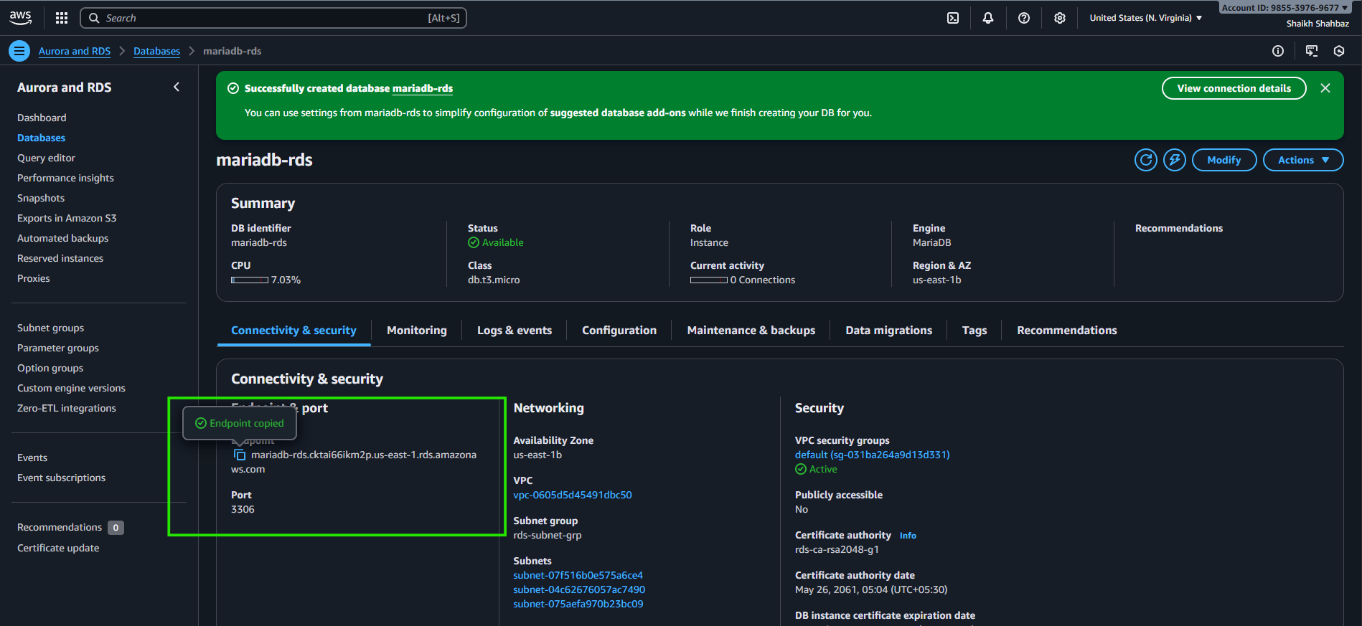
Validation 1: Resource Health
Ensure RDS instance status = “Available”
Evidence:
• RDS status screenshot
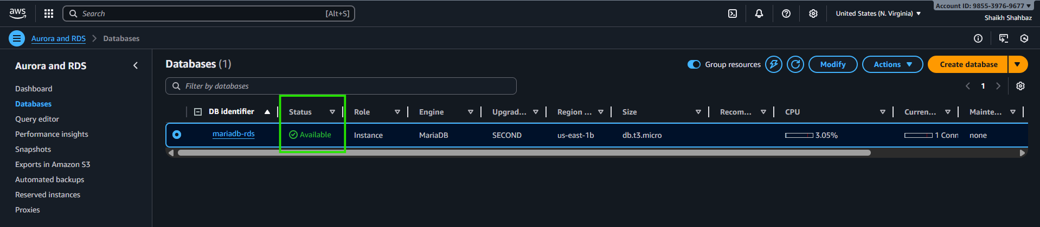
Issues Faced
• RDS connectivity failed initially → Fixed by allowing EC2 SG inside RDS SG.
• Import error for charset → Fixed by adding utf8 default charset.

Conclusion
MariaDB RDS instance was successfully launched, and the EC2 database was migrated using mysqldump restore. All data is now hosted on RDS with managed backups and better reliability.

5.Migrate database from EC2 to RDS.
Task title
Migrate Database from EC2
Objective
MariaDB database backup from EC2 to the RDS instance.
Prerequisites
List all requirements before starting:
• VPC
• Public & Private Subnets
• DB Subnet Group (Mandatory)
• Security Group allowing port 3306
• EC2 instance
• company-backup.sql file present on EC2
• Route Tables correctly configured

Steps :
mysql -h mariadb-rds.cktai66ikm2p.us-east-1.rds.amazonaws.com\
--ssl-ca=us-east-1-bundle.pem \
-u admin -p
Explanation:
Verifies that EC2 can communicate with the RDS instance.
Evidence:
MySQL welcome screen screenshot
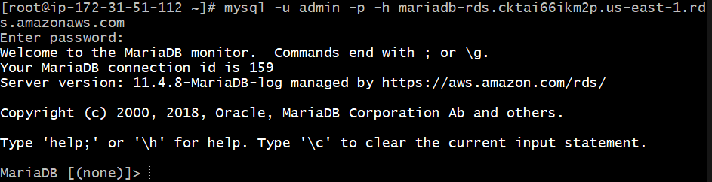
Step 5: Create Target Database on RDS
Inside MySQL:
CREATE DATABASE company;
USE company;
Explanation:
Creates an empty DB to import our backup.
Evidence:
SHOW DATABASES; screenshot
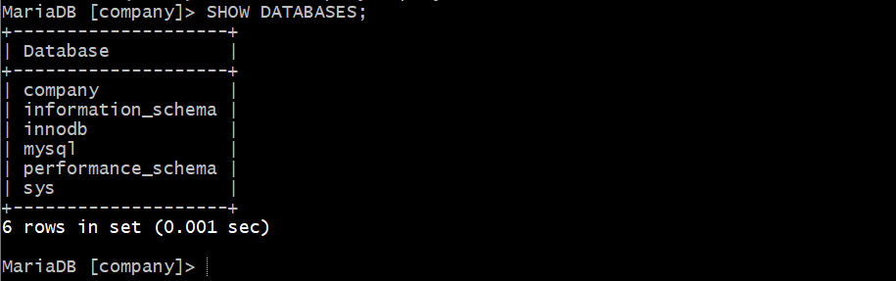
Step 6: Import Backup File to RDS
Command (run on EC2):
mysql -u admin -p -h <RDS-endpoint> company < company-backup.sql
Explanation:
Restores full schema and data into RDS database.
Evidence:
• Terminal output showing no errors
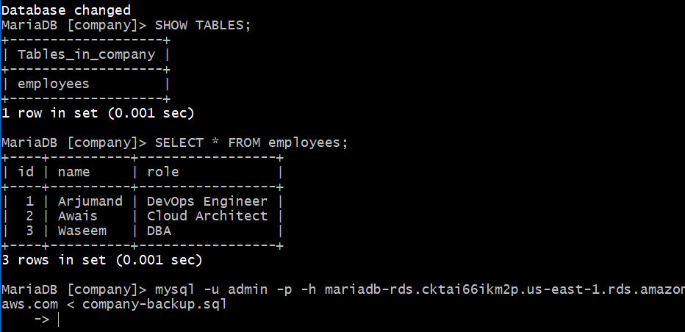
Step 7: Validate Imported Data
Command:
mysql -u admin -p -h <RDS-endpoint>
USE company;
SELECT * FROM employees;
Explanation:
Ensures migration success.
Evidence:
• Table rows screenshot
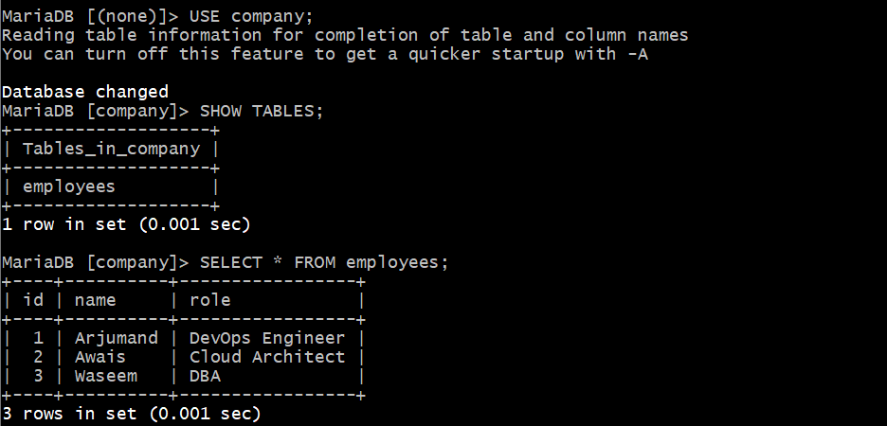
Validation Steps
Validation 2: Functional Check
Data matches original EC2 MariaDB data.
Evidence:
• SELECT * FROM employees on RDS
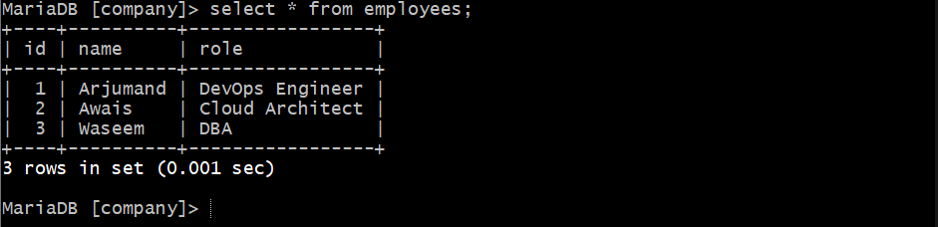

Validation 4: Access Check
Ensure only EC2 SG is allowed to connect.
Evidence:
• RDS inbound SG rules screenshot
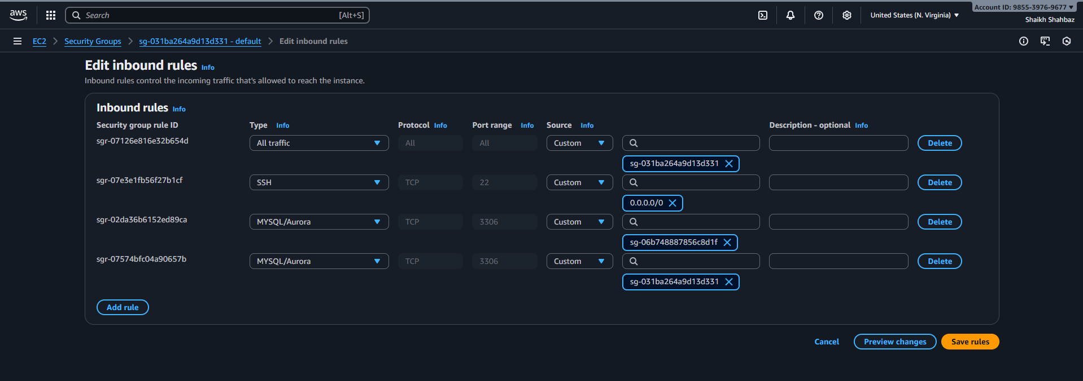
Issues Faced
• RDS connectivity failed initially → Fixed by allowing EC2 SG inside RDS SG.
• Import error for charset → Fixed by adding utf8 default charset.

Conclusion
MariaDB RDS instance was successfully launched, and the EC2 database was migrated using mysqldump restore. All data is now hosted on RDS with managed backups and better reliability.

6.Install MySQL DB on EC2.
Task Title
Install MySQL Server on EC2 Instance
Objective
Install and configure MySQL database on an EC2 instance for testing, administration, and comparison with MariaDB/RDS environments.
Prerequisites
• EC2 Instance (Amazon Linux 2023 preferred)
• Security Group with port 3306 open (only for testing; restrict later)
• Key Pair
• SSH Access
• Internet Access (Public EC2)
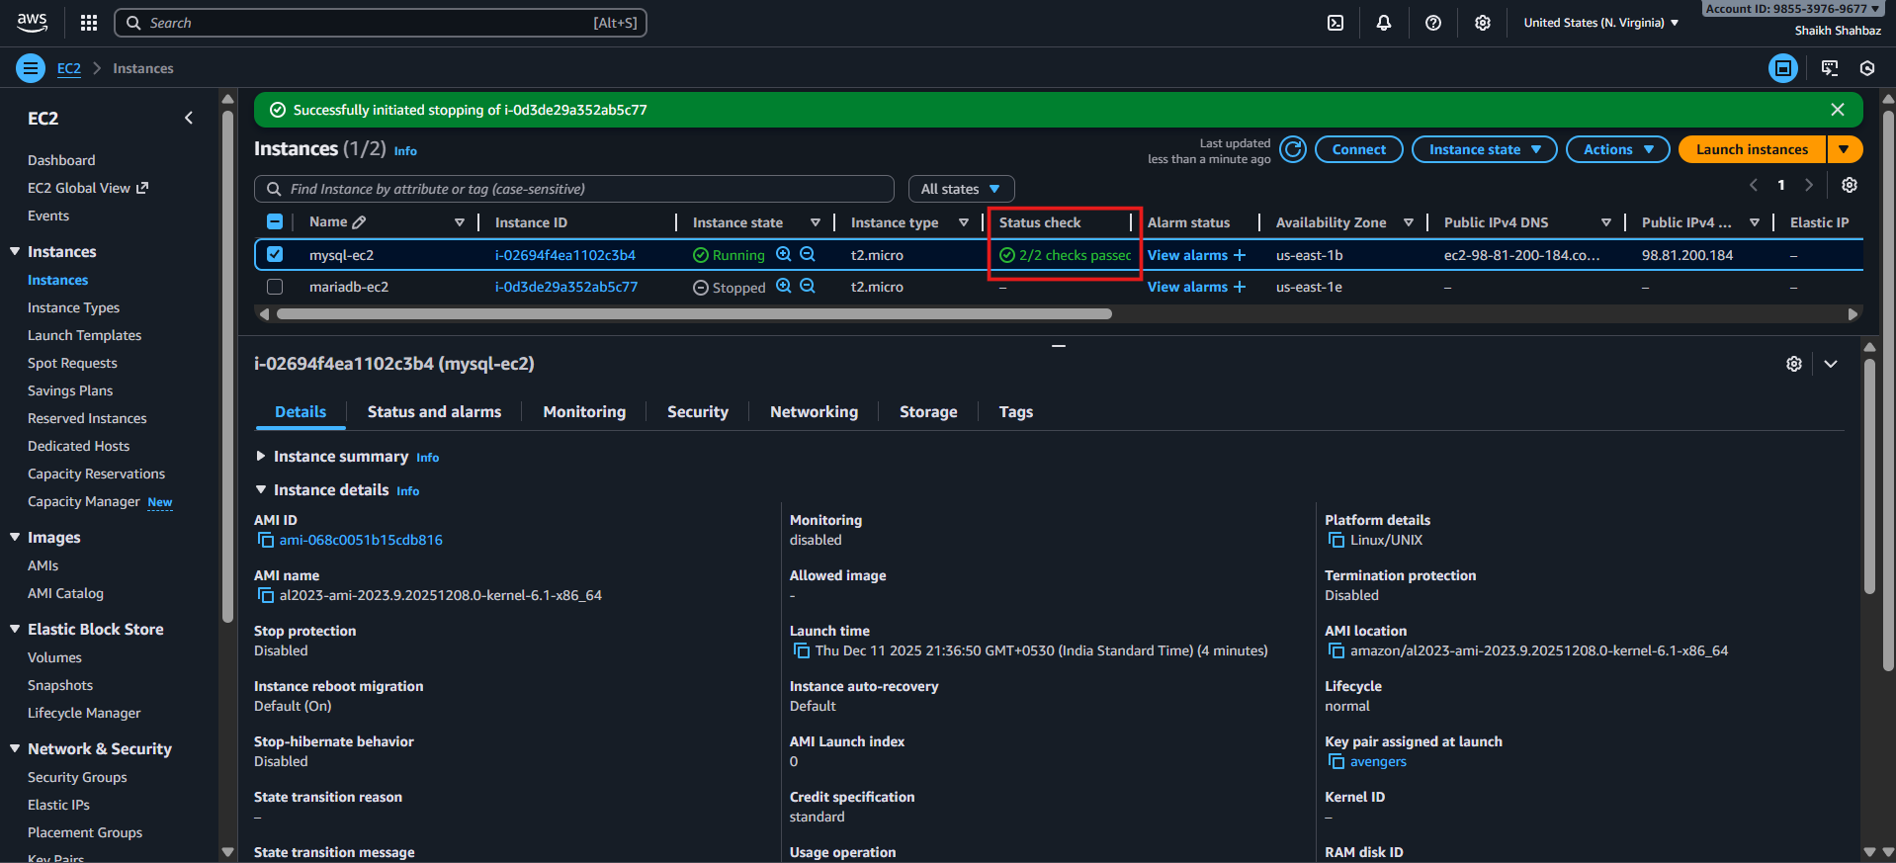
Step-by-Step Implementation.
Step 1: Update system packages
Command:
sudo yum update -y
Explanation:
Updates all system dependencies before installing MySQL.
Evidence:
(Attach screenshot of package update)
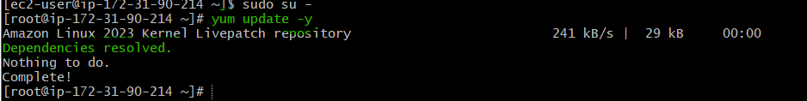
Step 1 — Install Required Dependencies
Command: write a bash script to install MySQL
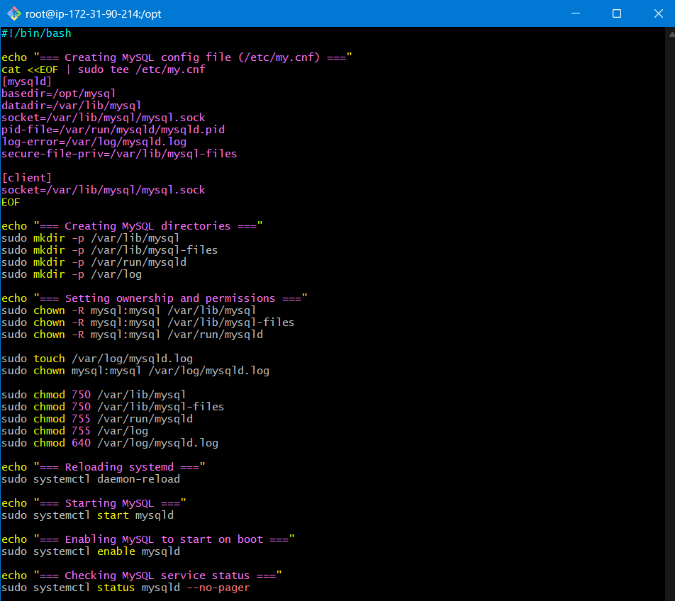
Step 2 — Check MySQL Service Status
Command:
sudo systemctl status mysqld
Expected Screenshot:
active (running)
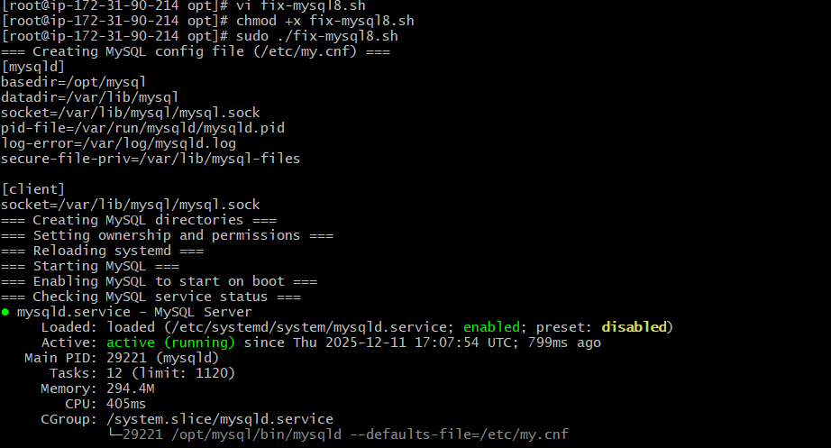
Step 3 — Log In and Change Root Password
Command:
sudo /opt/mysql/bin/mysql -u root -p
Then:
ALTER USER 'root'@'localhost' IDENTIFIED BY 'NewStrongPass#123';
Step 4: Log in to MySQL
Command:
mysql -u root -p
Evidence:
Screenshot of successful MySQL login.
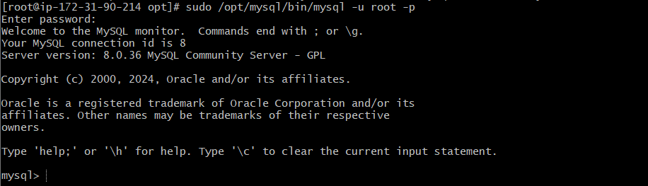

Step 5: Create test database + table (optional but recommended)
Inside MySQL:
CREATE DATABASE testdb;
USE testdb;

CREATE TABLE employees (id INT AUTO_INCREMENT PRIMARY KEY,
name VARCHAR(50),role VARCHAR(50));

INSERT INTO employees (name, role) VALUES
('Awais', 'DevOps Engineer'),('Arjumand', 'Cloud Engineer');
Evidence:
Screenshot of INSERT and SELECT results.
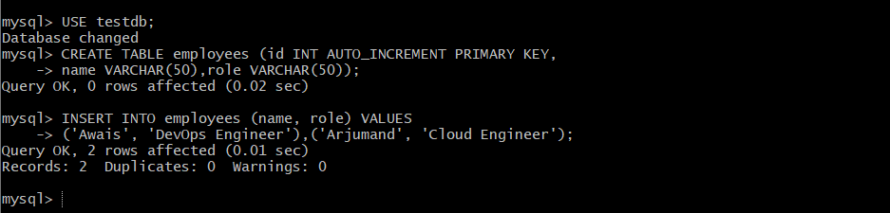
Validation Steps (With Evidence)

Validation 1: MySQL service health
Command:
sudo systemctl status mysqld
Expected:
active (running)
Evidence: Screenshot
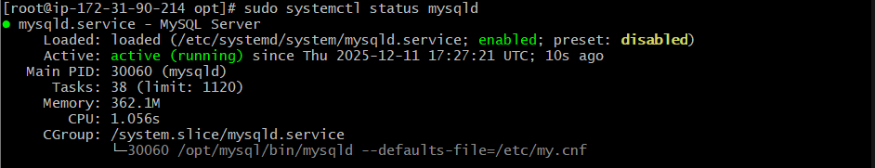
Validation 2: Functional test
Command inside MySQL:
SELECT * FROM testdb.employees;
Evidence: Screenshot of rows returned.
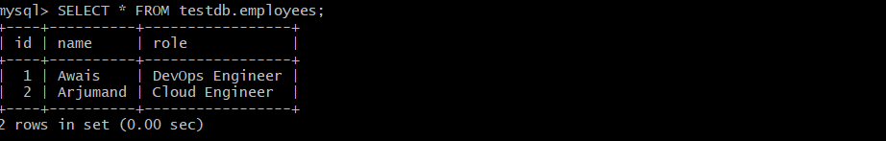
Validation 3: Network check (only if remote access needed)
Command (from EC2):
sudo ss -tulpn | grep 3306
Expected:
MySQL is listening on port 3306 locally.
Evidence: Screenshot
Issues Faced
Common issues:
- Port 3306 blocked → Fix by adding correct SG rules
- MySQL not starting → Run sudo journalctl -u mysqld
- Authentication plugin mismatch → Use ALTER USER… IDENTIFIED WITH mysql_native_password
Conclusion
MySQL is successfully installed, running, secured, and tested on EC2.

7.Launch MySQL RDS image.
Task Title
Launch a MySQL RDS Instance
Objective
Deploy a managed MySQL RDS database in AWS, configure networking and credentials, and ensure the DB becomes available for application use.
Prerequisites
• VPC
• Public & Private Subnets (DB must go in private subnet)
• Security Group for RDS
• Security Group for EC2 (if connecting)
• DB Subnet Group
• Route Tables configured
• Internet access only if using RDS public access
• MySQL Client installed on EC2 (for validation)

Step-by-Step Implementation (With Evidence)

Step 1: Open the RDS Console
Console Path:
AWS Console → RDS → Databases → Create Database
Explanation:
Start the workflow to launch a new RDS instance.
Evidence:
(Screenshot of RDS “Create Database” page)
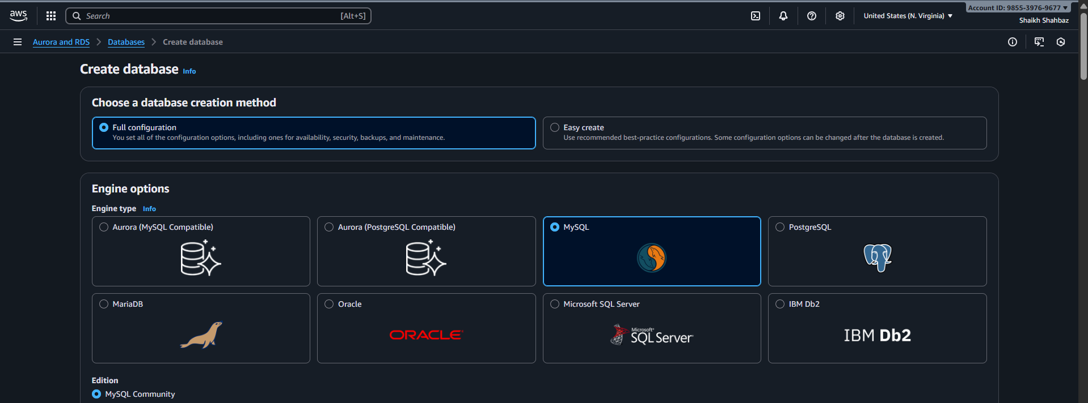
Step 2: Select Database Creation Method
Choose:
✔ Standard Create
Explanation:
Gives full control over engine, version, instance size, networking.
Evidence:
(Screenshot of “Standard Create” selected)
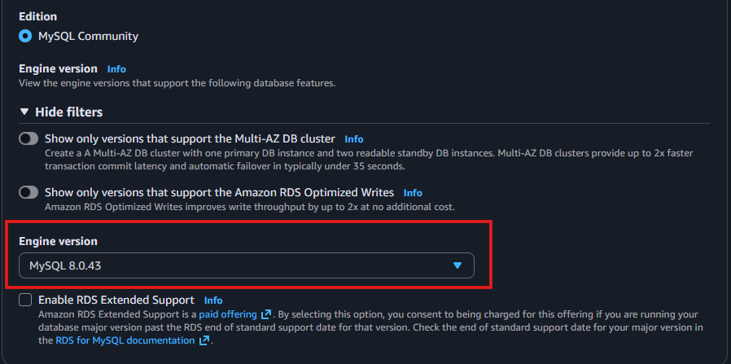
Step 3: Choose the Engine
Select:
✔ MySQL
Version → Latest (e.g., 8.x)
Explanation:
MySQL RDS engine will run your application’s database workload.
Evidence:
(Screenshot of engine selection)
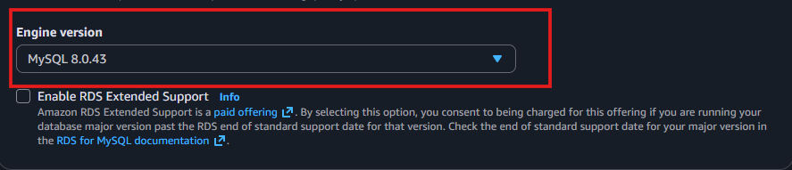
Step 4: Choose Template
Select:
✔ Free Tier (for practice)
OR
✔ Production (for real deployments)
Explanation:
Controls performance, backups, and instance type defaults.
Evidence:
(Screenshot showing template selection)
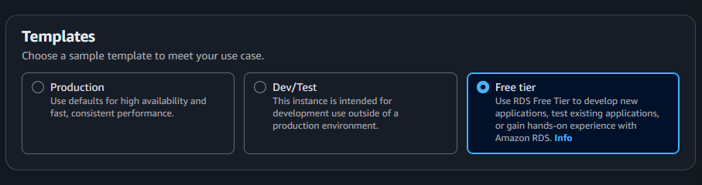
Step 5: Set DB Instance Identifier
Example:
mysql-rds-demo
Explanation:
This becomes the name of your RDS instance.
Evidence:
(Screenshot of DB instance name field)
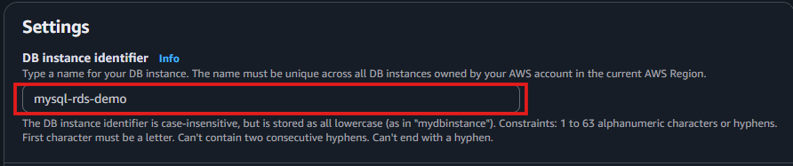
Step 6: Configure Credentials
Master username:
admin
Master password:
Enter a strong password → confirm it.
Explanation:
Credentials needed for application/EC2 connection.
Evidence:
(Screenshot of username/password fields)
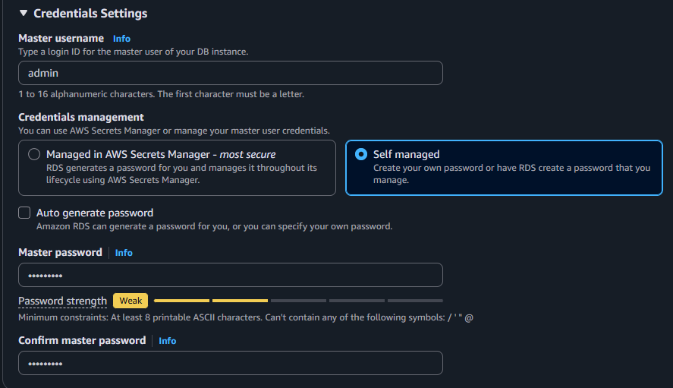
Step 7: Choose Instance Size
Example (Free Tier):
✔ db.t3.micro
✔ 1 vCPU, 1 GiB RAM
Explanation:
Defines compute resources for DB.
Evidence:
(Screen of instance class selection)
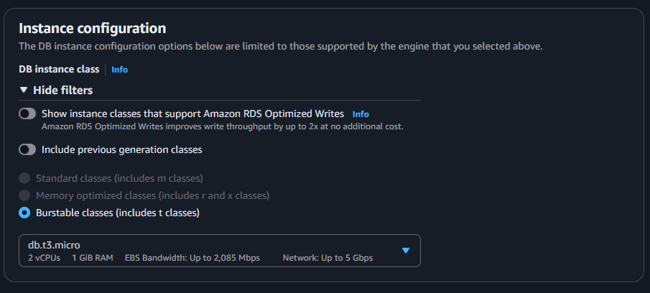
Step 8: Storage Configuration
Storage type:
✔ General Purpose (SSD)
Allocated Storage:
✔ 20 GiB (default)
Enable Storage Autoscaling:
✔ Optional
Explanation:
Choose storage capacity and scaling behavior.
Evidence:
(Screenshot of storage settings)
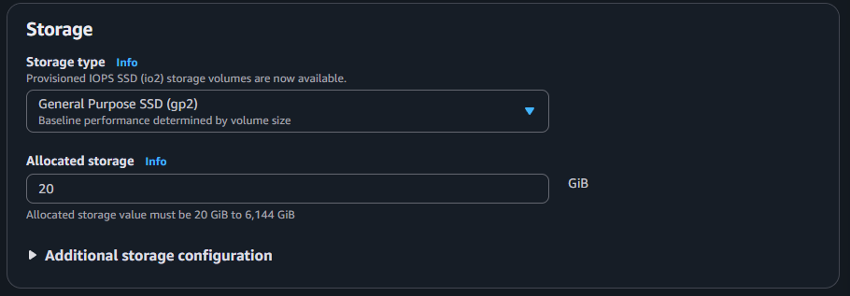
Step 9: Configure Connectivity
Network Section
• VPC → Select your project VPC
• Subnet Group → Private-subnet DB group
• Public Access → No
• VPC Security Group → Select/create SG
SG Rule:
Allow inbound on port 3306 from EC2 SG.
Explanation:
Ensures MySQL is reachable only internally.
Evidence:
(Screenshot of connectivity settings)
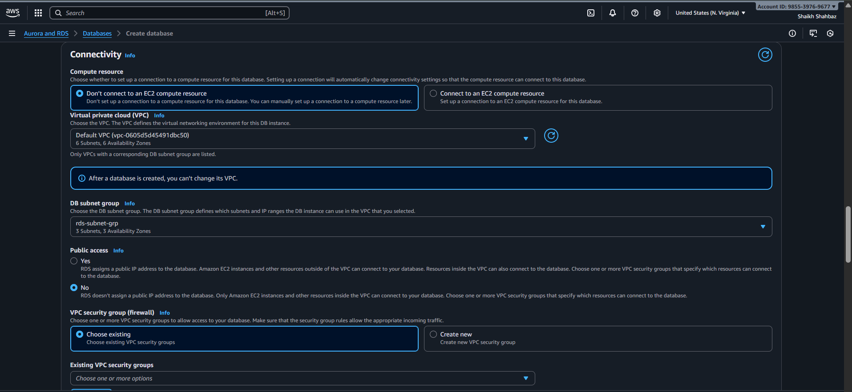
Step 10: Additional Configurations
• Initial Database Name → shahbazDB
• Backup retention → 1 days (or as required)
• Maintenance window → Auto or custom
• Monitoring → Optional
Explanation:
Sets up backup strategy and maintenance behavior.
Evidence:
(Screenshot of “Additional Configuration” section)
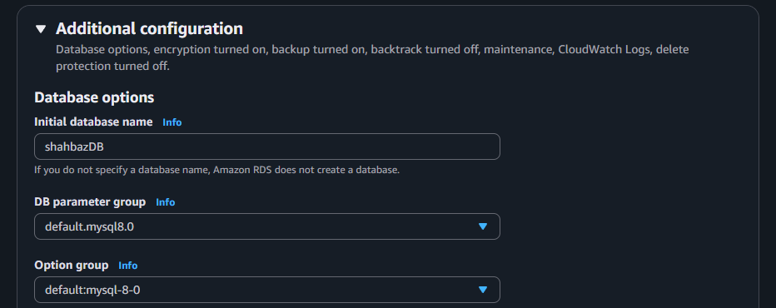
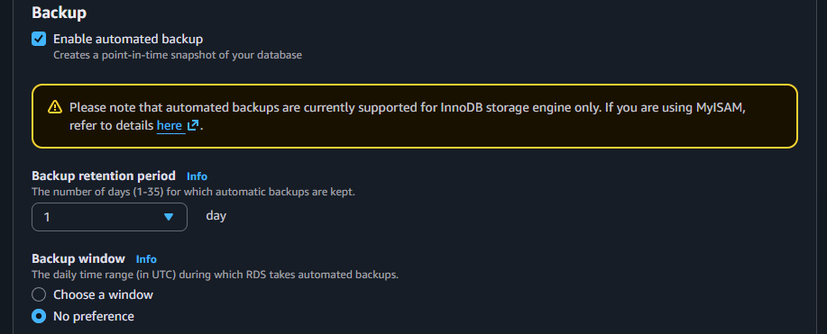
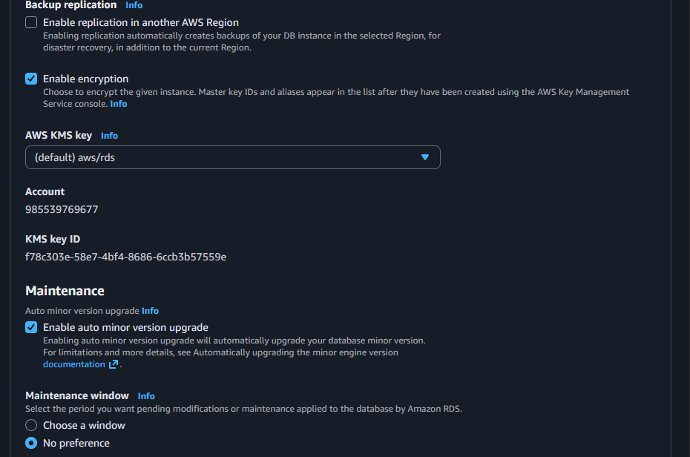
Step 11: Create the RDS Instance
Click:
✔ Create Database
Explanation:
RDS is now being provisioned.
Evidence:
(Screenshot showing "Creating" status)
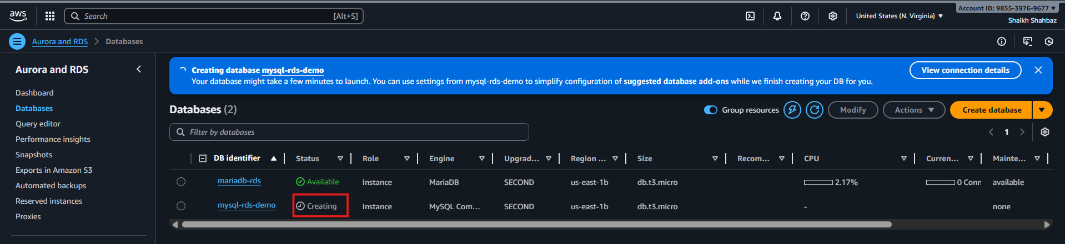
Step 12: Wait for Status → “Available”
Console Path:
RDS → Databases → mysql-rds-demo → Status: Available
Explanation:
Your DB is ready to accept connections.
Evidence:
(Screenshot of “Available” status with endpoint visible)
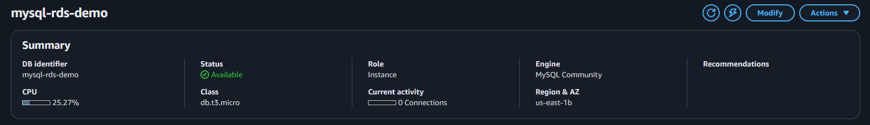
Validation Steps

Validation 1: Resource Health
Check:
RDS instance → Status Available
Evidence:
Screenshot of RDS dashboard.
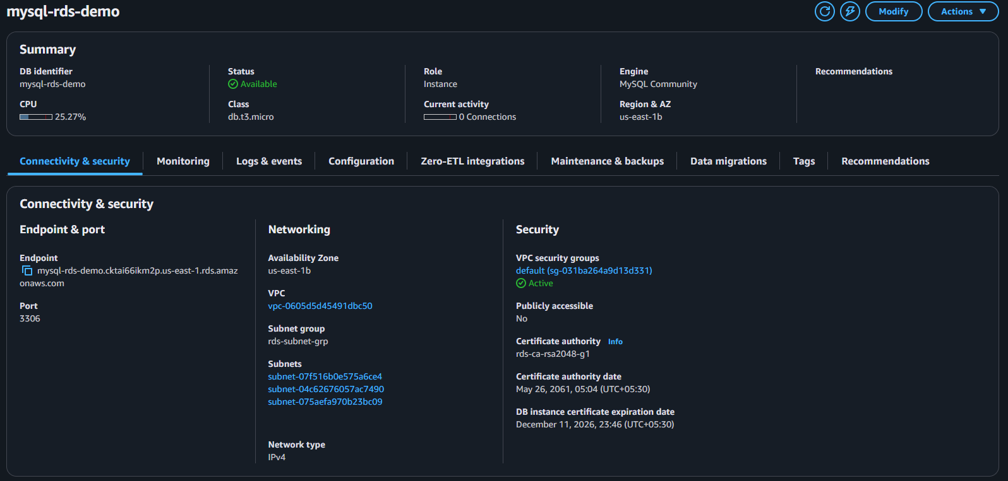
Validation 2: Network Connectivity
From EC2:
telnet <rds-endpoint> 3306
Evidence:
Terminal showing successful connection.
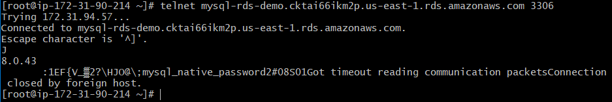
Validation 3: Login Test
From EC2:
mysql -u admin -p -h <rds-endpoint>
Evidence:
Screenshot showing login success.
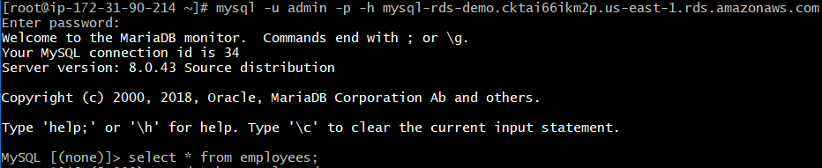
Issues Faced (Optional)
Issue:
EC2 cannot connect to RDS
Cause:
Missing SG rule
Fix:
Added inbound rule: EC2-SG → RDS-SG → port 3306

Conclusion
Successfully launched a MySQL RDS Instance with proper engine selection, networking, storage configuration, and validated connectivity from EC2.

8.Configure Multi-AZ.
Task Title
Enable Multi-AZ for MySQL RDS Instance
Objective
Configure Multi-AZ deployment to provide high availability and automatic failover for the MySQL RDS instance.
Example: Convert a single-AZ RDS instance to Multi-AZ for improved durability.
Prerequisites
• VPC
• Private Subnets in at least two Availability Zones
• DB Subnet Group with subnets in AZ-A & AZ-B
• MySQL RDS instance (running)
• Security Groups
• Route Tables
• No pending maintenance on RDS

Step-by-Step Implementation (With Evidence)

Step 1: Open the RDS Console
Console Path:
AWS Console → RDS → Databases → Select your MySQL RDS instance
Explanation:
We start by accessing the DB settings to modify availability.
Evidence:
(Screenshot of selected MySQL RDS)
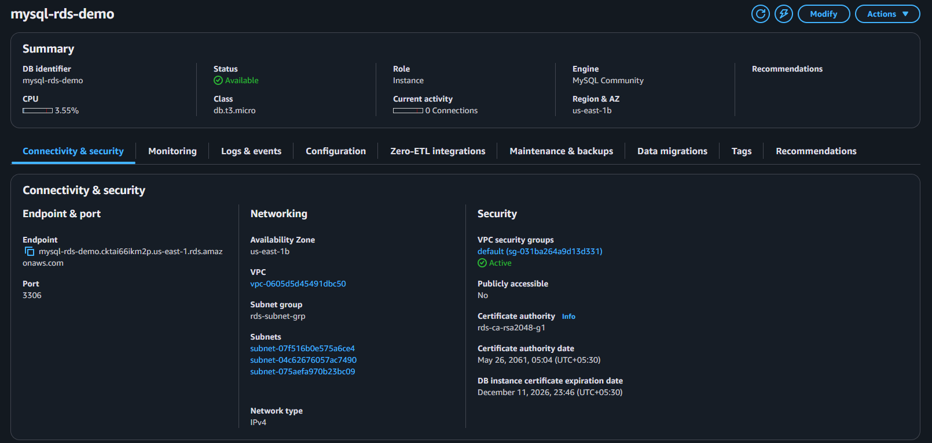
Step 2: Click “Modify”
Console Path:
Actions → Modify
Explanation:
Allows you to change configuration of an existing RDS instance.
Scroll to “Availability & Durability” Section
Select:
✔ Multi-AZ DB instance
(Do NOT select Multi-AZ cluster unless required)
Explanation:
Enables synchronous replication to a standby instance in another AZ.
Evidence:
(Screenshot of Multi-AZ option selected)
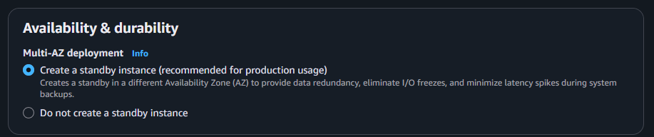
Step 4: Choose the Deployment Type
Choose:
✔ Multi-AZ DB Instance (One standby)
Explanation:
AWS will automatically deploy a second copy in another Availability Zone.
Evidence:
(Screenshot of AZ settings)
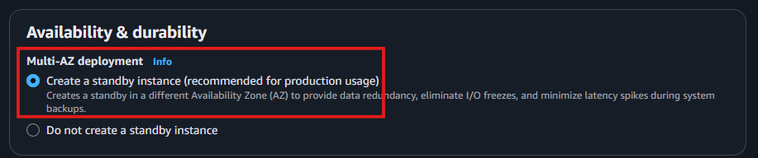
Step 5: Apply Changes
At the bottom choose:
✔ Apply Immediately (if allowed)
or
✔ Apply during next maintenance window (recommended for production)
Explanation:
Applies the Multi-AZ configuration.
Step 7: Wait for Status = “Available”
Check:
RDS → Databases → DB Status
Available
Multi-AZ: Yes
Explanation:
RDS now has 2 synchronous DB nodes across AZs.
Evidence:
(Screenshot showing “Multi-AZ: Yes”)
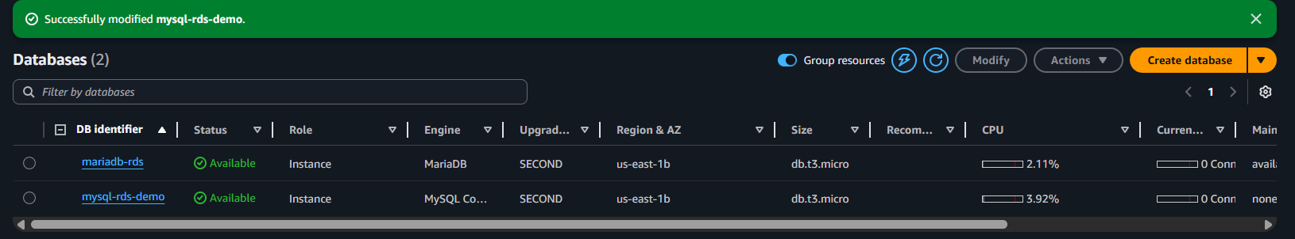
Validation Steps (Mandatory)

Validation 1: Resource Health
Check:
DB status = Available
Multi-AZ = Yes
Secondary AZ visible
Evidence:
RDS dashboard screenshot
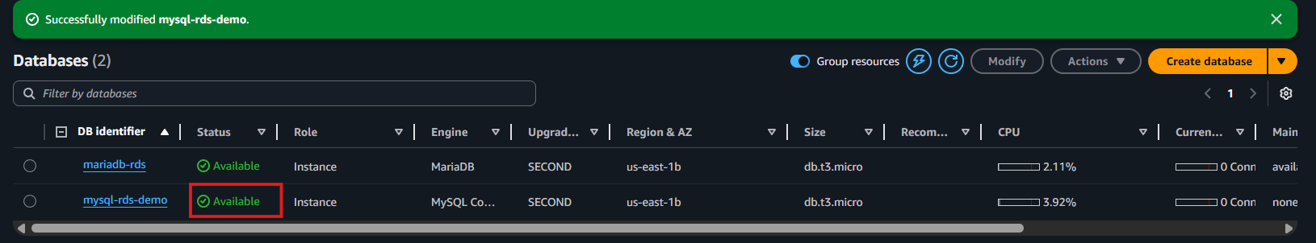
Validation 2:Reboot with Failover
Console Path:
RDS → Databases → Actions → multi-AZ-zones
What Happens:
Modifying to multi availability zones
Evidence:
Screenshot showing new AZ as primary
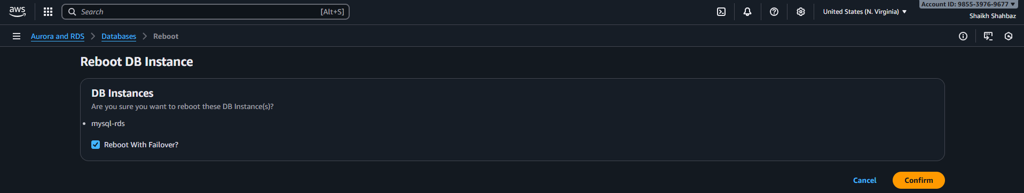
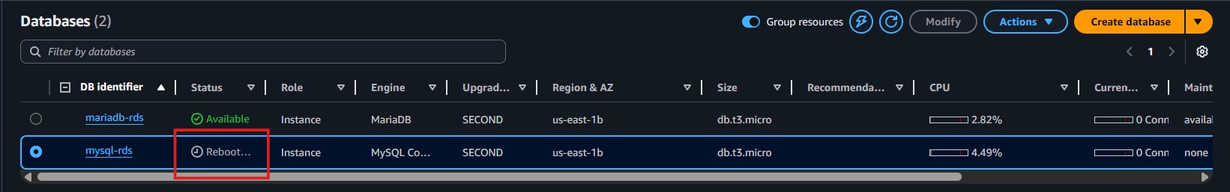
Validation 3: Application Connectivity
From EC2:
mysql -u admin -p -h <rds-endpoint>
Check:
Connection stays active before & after failover (few seconds downtime).
Evidence:
Terminal screenshot
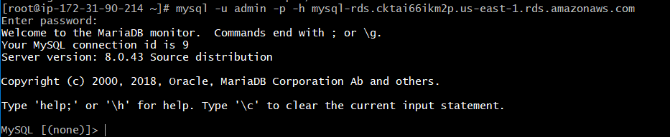
Validation 4: Network Check
From EC2:
telnet <rds-endpoint> 3306
Expected:
Connection successful
Evidence:
Screenshot showing TCP connection
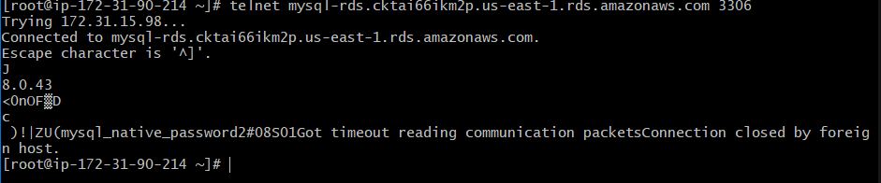
Issues Faced
Issue | Cause | Fix
“Cannot enable Multi-AZ” | Subnet group has only 1 AZ | Add subnet in second AZ
“Apply Immediately disabled” | Storage or class mismatch | Choose compatible instance class
Connection timeout | SG misconfigured | Allow EC2-SG → RDS-SG on port 3306

Conclusion
Multi-AZ is successfully enabled, ensuring high availability, synchronous replication, and automatic failover for the MySQL RDS instance.

9.Take backup of DB and restore the DB.
Task Title
Take Backup of MySQL RDS and Restore the Database

Objective
Create a manual snapshot of the MySQL RDS instance and restore it to a new RDS instance for validation and disaster recovery testing.

Prerequisites
• MySQL RDS instance running
• VPC
• Private Subnets
• RDS Subnet Group
• Security Groups
• IAM Role (optional)
• EC2 instance with MySQL client (for validation)
• Database name, credentials
• Permissions to perform RDS snapshot operations

Step-by-Step Implementation

Step 1: Open the RDS Console
Console Path:
AWS Console → RDS → Databases → Select your MySQL RDS instance
Explanation:
We start by selecting the DB to back up.
Evidence:
(Screenshot of selected RDS instance)
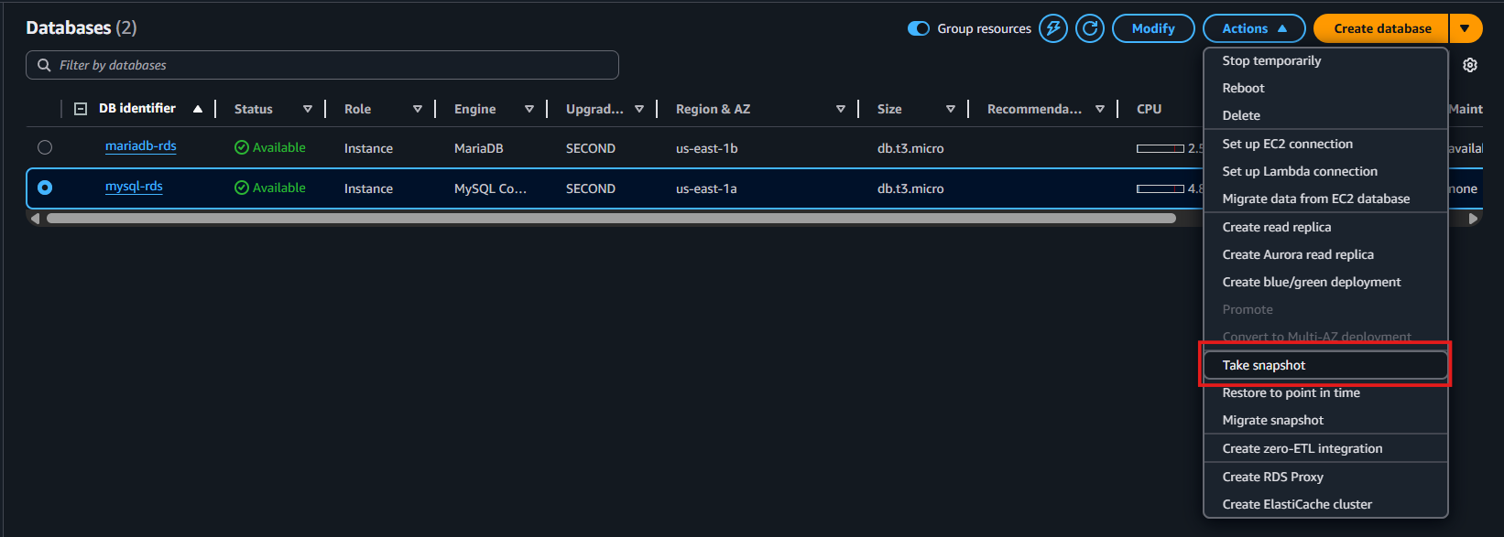
Step 2: Create a Manual Snapshot
Console Path:
Actions → Take snapshot
Enter Snapshot Name:
mysql-rds-backup-01
Explanation:
Creates a full backup of the DB stored in Amazon S3.
Evidence:
(Screenshot of snapshot creation popup)
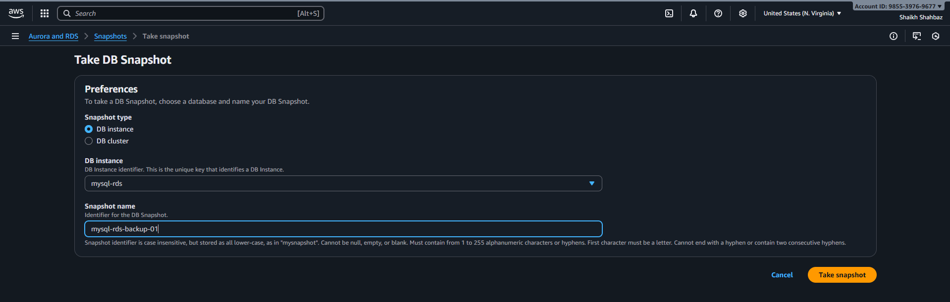
Step 3: Wait for Snapshot to Complete
Console Path:
RDS → Snapshots → Status: Creating → Available
Explanation:
Backup is ready once status becomes “Available”.
Evidence:
(Screenshot of snapshot “Available” status)
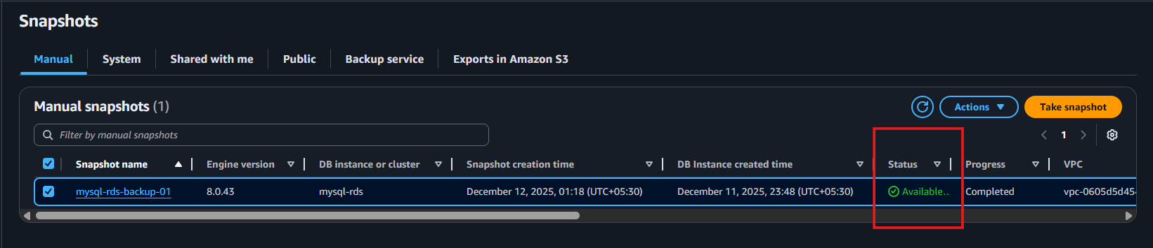
Step 4: Restore DB From Snapshot
Console Path:
RDS → Snapshots → Select your snapshot → Actions → Restore Snapshot
Enter New DB Identifier:
mysql-rds-restore-demo
Choose Settings:
• DB instance class → t3.micro
• Multi-AZ → Optional
• Storage → Same as original
• VPC → Same VPC
• Subnet Group → Private DB subnet
• Security Group → Same as original or new one
• Public Access → No
Explanation:
Restores DB to a brand-new RDS instance using snapshot data.
Evidence:
(Screenshot of “Restore snapshot” configuration)
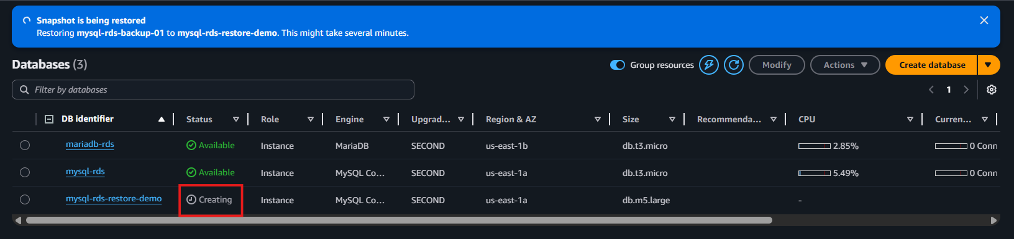
Step 5: Launch Restored Instance
Click:
✔ Restore DB Instance
Explanation:
AWS provisions a new RDS instance from the snapshot.
Evidence:
(Screenshot showing status “Creating”)

Step 6: Wait for Restored DB to Become Available
Console Path:
RDS → Databases → mysql-rds-restore-demo
Status should become:
Available
Explanation:
Restored DB is now ready to use.
Evidence:
(Screenshot showing “Available” status with endpoint)
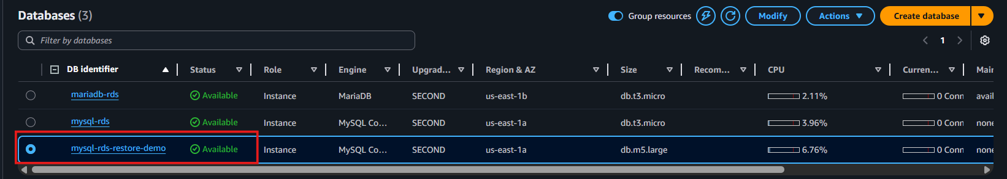
Step 7: Validate Restored DB from EC2
SSH into EC2 and run:
mysql -u admin -p -h <restored-rds-endpoint>
Then:
SHOW DATABASES;
Explanation:
Confirms that restored DB contains the same data as the original.
Evidence:
(Provide screenshot of query results)
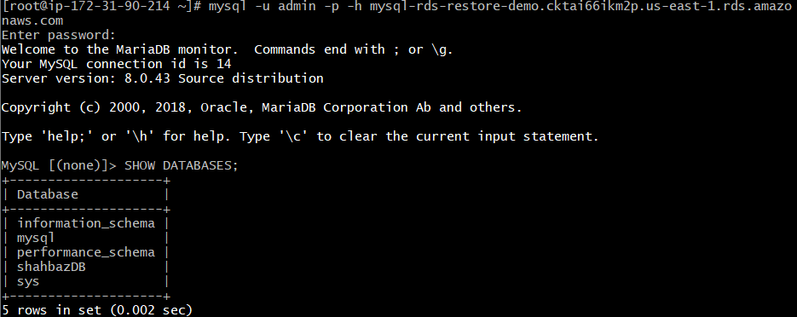
Validation Steps (Mandatory, With Evidence)

Validation 1: Snapshot Validation
Check:
Snapshot status = Available
Evidence:
(RDS snapshot screenshot)

Validation 2: Restore Validation
Check:
Restored RDS instance = Available
Evidence:
(Screenshot of restored DB)
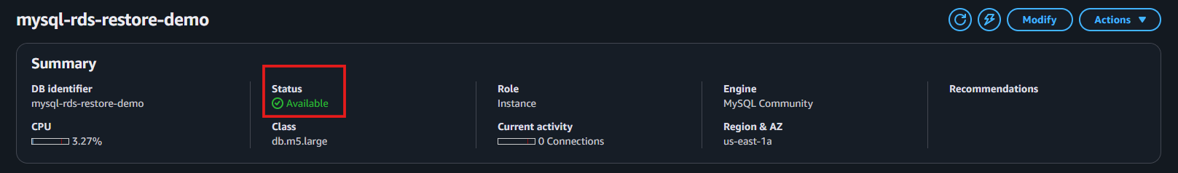
Validation 3: Functional Database Validation
Check:
Successfully connect and query restored DB.
Commands:
mysql -u admin -p -h <restored-rds-endpoint>
SHOW DATABASES;
Evidence:
Screenshot shows correct rows restored.

Validation 4: Network Connectivity
From EC2:
telnet <restored-rds-endpoint> 3306
Expected:
Connected successfully.
Evidence:
Terminal screenshot.
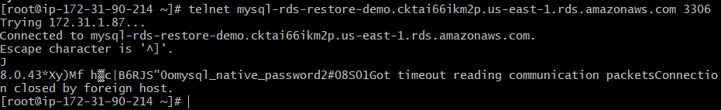
Issues Faced (Optional)
Issue | Cause | Fix
Snapshot stuck in “creating” | Heavy I/O on DB | Wait or reduce write load
Cannot restore snapshot | Wrong subnet group | Use DB subnet group with 2+ AZs
EC2 cannot connect | Wrong SG rules | Add inbound rule from EC2-SG → RDS-SG

Conclusion
Successfully created a manual backup of the MySQL RDS instance and restored the database to a new RDS instance. Data and schema are fully preserved and verified.

10.Create read replica.
Task Title
Create Read Replica for MySQL RDS
Objective
To create a highly available and scalable read replica of the primary MySQL RDS instance for improved performance and disaster recovery.
Prerequisites
• Existing MySQL RDS instance (Primary)
• RDS Subnet Group
• Security Group allowing traffic from application EC2
• Proper IAM permissions (RDSFullAccess recommended)
• VPC + Private Subnets for RDS

Step-by-Step Implementation

Step 1: Open RDS Dashboard
Console Path:
AWS Console → RDS → Databases
Action: Select your primary RDS instance.
Evidence:
(Use your screenshot similar to this)
[Primary RDS selected screenshot]
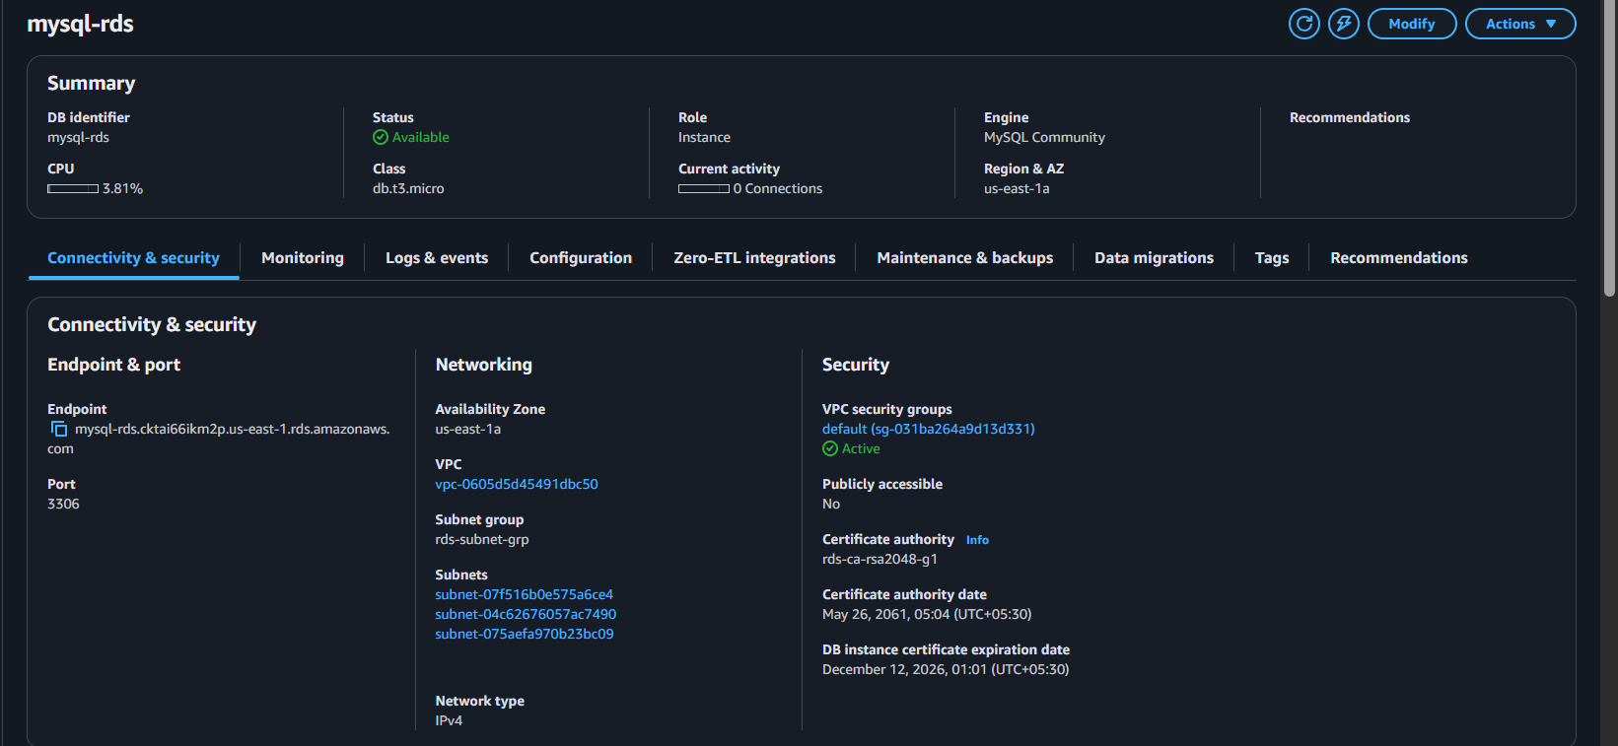
Step 2: Create Read Replica
Console Path:
RDS → Databases → Select primary RDS → Actions → Create read replica
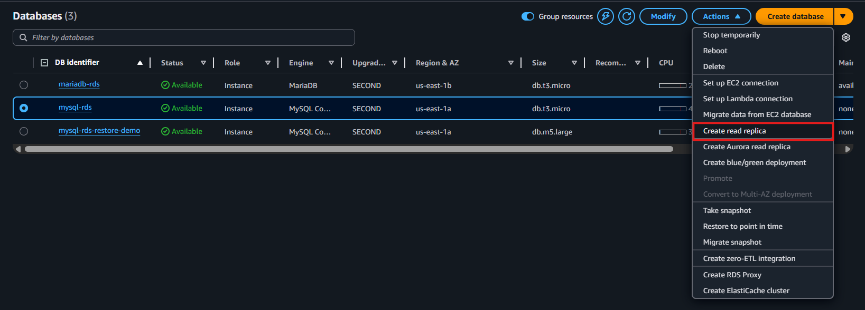
Configure:
• DB instance identifier: mysql-db-read-replica
• DB instance class: Same or smaller than primary
• Multi-AZ: Optional
• Storage: Same as primary
• VPC: Same VPC
• Subnet group: Select DB subnet group
• Security group: Allow app traffic
• Public access: NO (recommended)
• Backup: Optional
Evidence:
[Create read replica configuration screenshot]
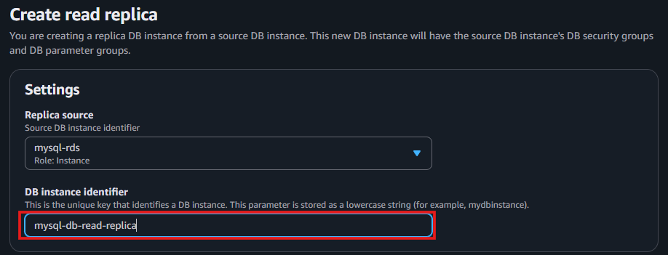
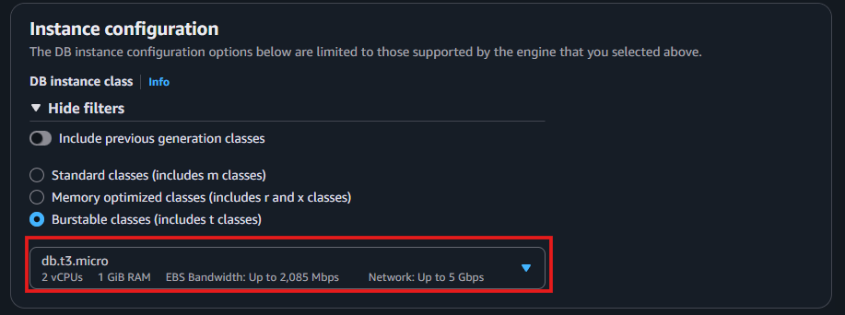
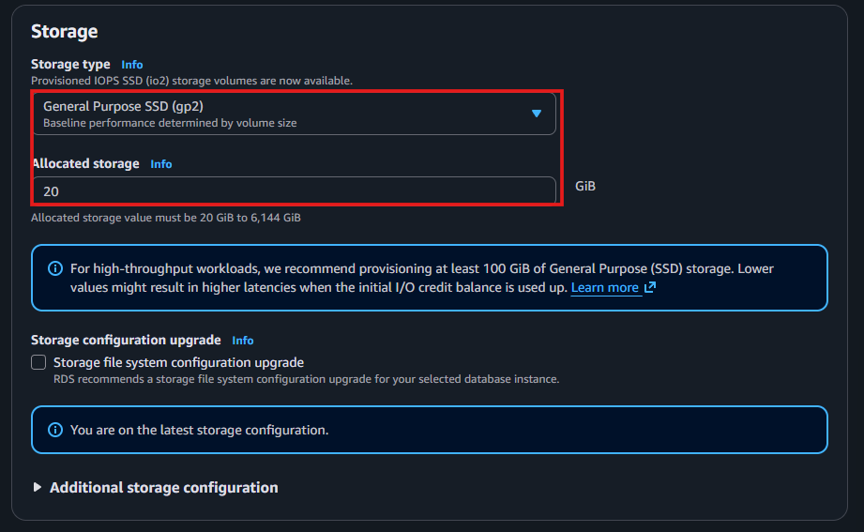
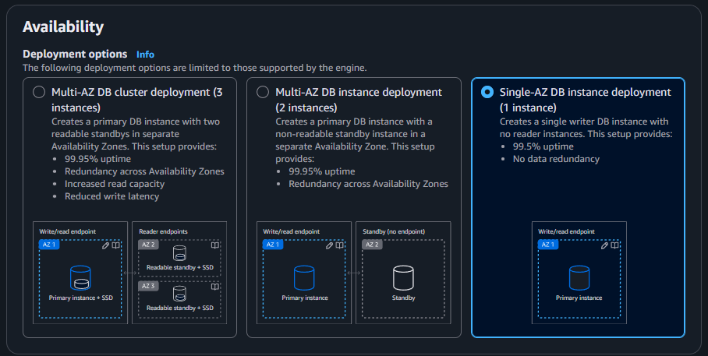
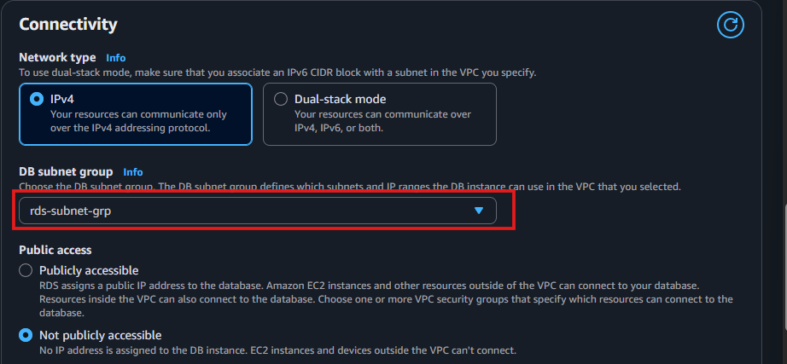
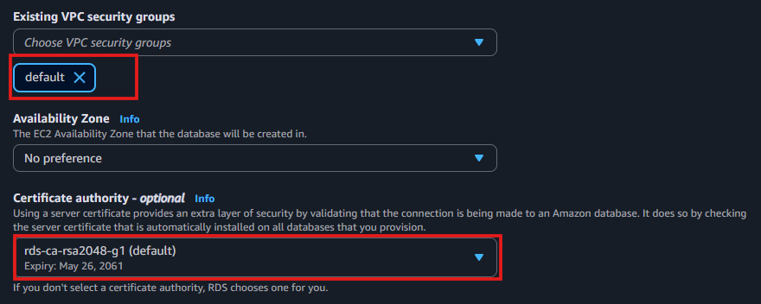
Step 3: Create the replica
Click Create read replica.
Expected Behavior:
Replica status will be creating → available.
Evidence:
RDS status: Creating
RDS status: Available
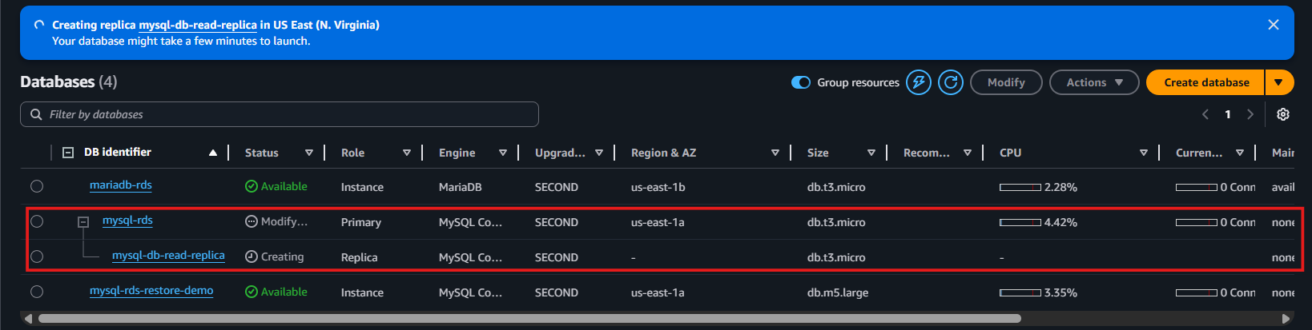
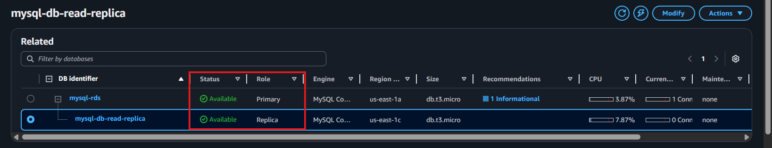
Step 4: Verify replication configuration
Open the replica → Configuration tab.
Check:
• Replication role: READ REPLICA
• Replication source: Primary instance name
• Replication status: Available
Evidence:
[Replication status screenshot]
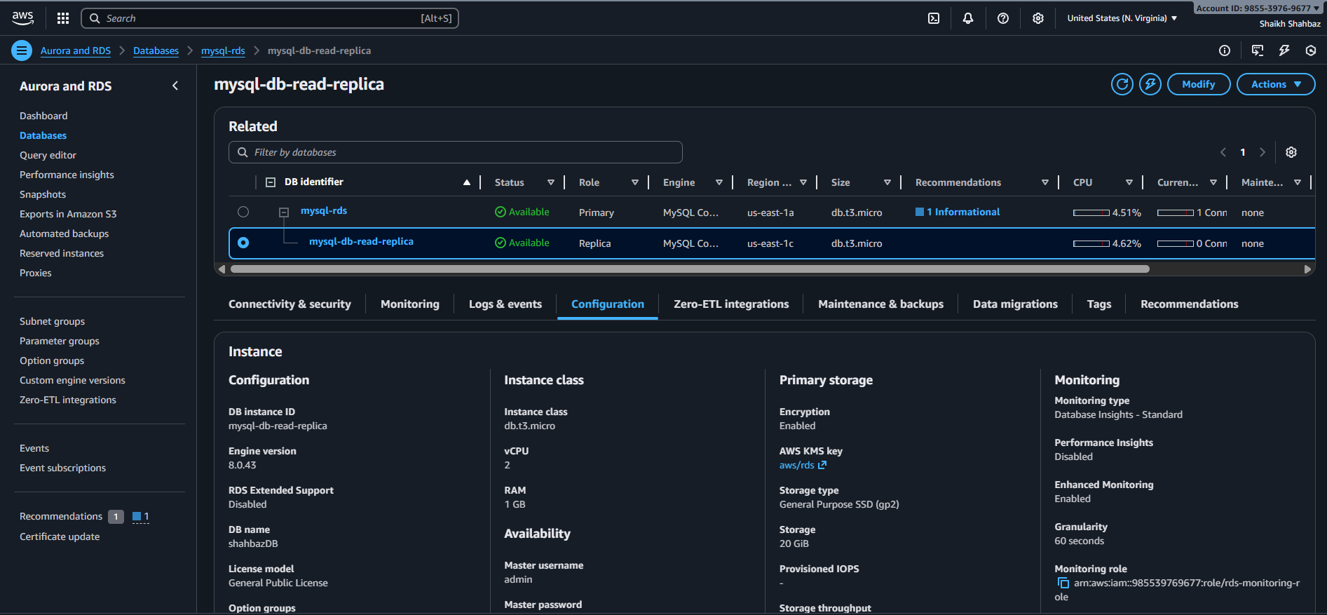
Step 5: Validate Read-Only Mode
Connect to the read replica:
mysql -h <replica-endpoint> -u admin -p
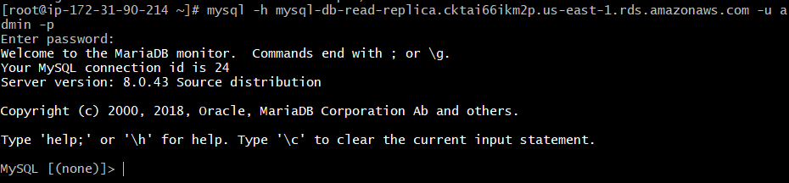
Run:
SHOW VARIABLES LIKE 'read_only';
Expected output:
Value: ON
Evidence:
read_only = ON
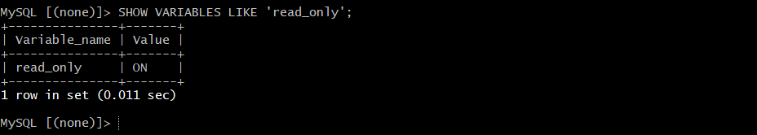
Validation Steps (Mandatory)

Validation 1: Resource Health
Replica status should be Available.
Evidence:
[Replica available screenshot]

Validation 2: Replication Health Check
Run:
SHOW SLAVE STATUS\G;
Check:
✔ Slave_IO_Running = Yes
✔ Slave_SQL_Running = Yes
✔ No replication errors
Evidence:
Slave_IO_Running: Yes
Slave_SQL_Running: Yes
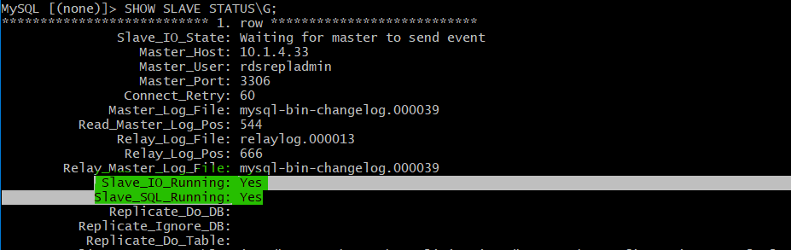

Issues Faced (Optional)
Issue | Fix
SG blocked replication port 3306 | Allowed inbound rule: Primary RDS → Replica
Replica stuck in creating | Rebooted primary + removed stale snapshots
KMS mismatch | Ensured same KMS key on both instances

Conclusion
A fully functional MySQL RDS Read Replica is created successfully.
Replication is healthy, read-only mode is enforced, and data sync is confirmed.

